Meeting commenced: 6:05 p.m.

Attendees:
Christine Vince, Principal; Joanne Schipper, Vice Principal; Theresa Hiff, Gr 2 Teacher; Lisa Turchansky, ECSD Trustee; Kate Faught, Chair; Emily Kaminsky, Treasurer; Brian Lema, Secretary; Efosa Sowa, Kofi Torpey, Sheeba Matthews-George, Karine Tapia Withers, Miranda

- Opening Prayer / Treaty Six Acknowledgement and Introductions
Led by Kate Faught. All participants introduced themselves and we had a warm welcome from Lisa Turchansky, ECSD Trustee.

- Approval of Agenda
Kate moved to accept the agenda. All in favour. Carried.

- Approval of Minutes from May 31 SAC Meeting
Kate recommended that we move this to the Oct. 25 meeting.

- Administrator Report – Christine Vince
Christine gave the following updates:

Introductions:
- Mrs. Schipper – Assistant Principal/Grade 3 teacher

Celebrations:
- School Opening Celebration – God Calls Us Each By Name






Updates & Information:

- Budget 2021-2022

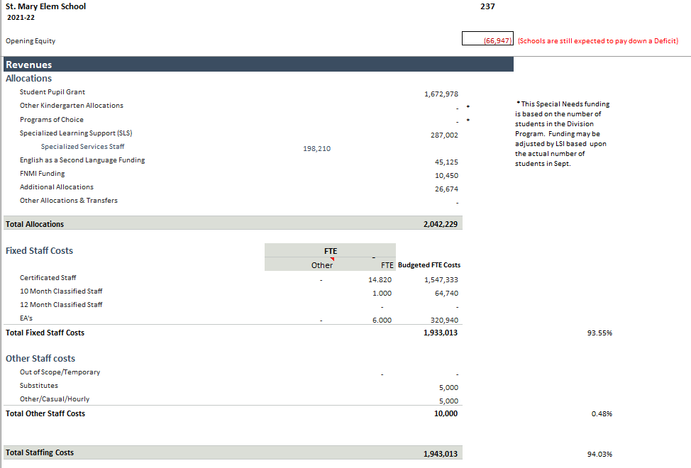

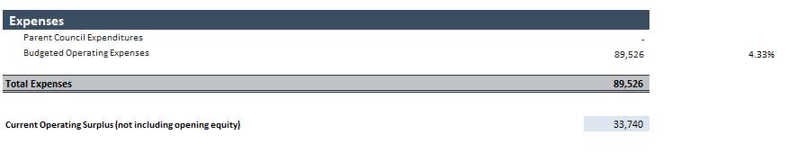
Advertising, Phone, Internet, Computer Supplies, Computer Equipment, Furniture/Fixtures, PD Costs, Custodial Supplies, Building Maintenance, Book Purchases, Instructional Supplies, Postage, Printing, Laminating

We are opening with a deficit of 66,947 and intend to pay down about half of that with our surplus from this year.

The bulk of our budget is for staffing. Last year was 92.45% compared to this year at 93.55%. Operational Expenses we will do our best to decrease to support our staffing needs. Last year was 5.29 % of allocations compared to this year at 4.33%.

- Enrolment 2021-2022 - Total 289
  - Kindergarten – 32
  - Grade 1 – 45
  - Grade 2 – 52
  - Grade 3 – 30
  - Grade 4 – 45
  - Grade 5 – 43
  - Grade 6 – 42

- Class Configurations 2021-2022
  - Kindergarten AM & Kindergarten PM
  - 1A & 1B,
  - 2A & 2B
  - 3A
  - 4A & 4B
  - 5A & 5B
  - 6A & 6B

Upcoming Events:
September 29 – Wear Orange – Truth & Reconciliation
September 30 – NO School for Truth & Reconciliation Day
October 2 – Custodian Appreciation Day
October 4 – Lifetouch Photos
October 5 – World Teacher Day
October 11 – Thanksgiving Day – No School
October 18 – No School (Faith Day) / Civic Elections
October 20 – Demonstration of Learning - Virtual
October 25 – SAC Annual General Meeting - Virtual
October 29 – Students are invited to dress up in a friendly costume for a Halloween Parade

Enrollment declined from what we were expecting in the Spring.

Emily asked if there was a chance that some of the online learners might return in February. Christine responded that it is definitely a possibility, but they are unable to plan for it as many changes are expected and unpredictable.

Kate asked if St. Monica was experiencing a similar decline in enrollment. Christine replied that she and Joanne will definitely work to recruit students, but one challenge is that the catchment area is much larger than St. Mary.

Kate asked if there were similar declines at the Public Schools. Christine was not sure what the enrollment was at Earl Buxton or other neighbourhood schools. General feedback from the group was that attendance was very strong at Earl Buxton.

Karine asked about the round-a-bout drop off and if there are spots that could be used by parents, and how many. Christine responded that she will look into this and see if we can get lines painted.

Christine welcomes feedback and any ideas people may have to increase enrollment.

- Financial Report
Emily reported that the Casino account is currently at $7,816.51 and the Operating account is at $15,185.85.

The Casino funds are from 2019 and those funds typically must be spent within 24 months, but we can request an extension of another 24 months (due to the pandemic).

The 2nd quarter of 2022 is when we are tentatively booked for our next Casino but that may change.

Motions were passed in May to provide each class with $400 in funding as well as purchase more Chromebooks ($15K). The $400 cheques will be signed off soon by SAC. The Chromebook needs assessment is underway. The school will provide the total dollar amount to SAC soon.

Kate asked if the school supported kids bringing their own Chromebook into the school. Teachers are okay with this and some students do bring their own, especially in the older grades. There are challenges with responsibilities (damage / repairs). Also, the school cannot mandate the parental purchase of Chromebooks for their children.

Miranda asked if there was a risk of money being clawed back by the district if funds are provided from the SAC. Christine stated that we are not at risk of that because the school is running a deficit.

Christine stated that Phys Ed equipment and the sensory room have had some upgrades. Recess bags may also be provided.

Christine said that a request was made for lower basketball hoops to accommodate the lower grades. Possible locations are being looked in to and a request for funds may be forthcoming.

Kate asked what the typical schoolboard ratio of Chromebooks to kids is. Christine said that it varies from school to school.

Efosa asked if the Kinders or Gr 1s use the Chromebooks. Christine responded that it is very limited in those grades. Grade 2 is when Chromebook use increases.

- SAC Community Building Initiatives
Combined this item with Fundraising Planning / Brainstorming

- Fundraising Planning / Brainstorming
Emily let Kate know that we technically should have a separate fundraising meeting. This will be established at the next meeting (AGM).

Event planning is challenged with the pandemic. Kate asked the group if we want to look at alternative fundraising.

The Read-a-Thon will still be a go, and it is a very effective fundraiser.

Brian suggested a write-a-cheque campaign. We’ll look at doing that in October.

- New Business

None.

Emily moved to adjourn, Kate seconded. Carried.

Meeting adjourned 7:36 p.m.

Next SAC Meeting: Annual General Meeting October 25, 2021 @ 6:00 PM

